UNITED STATES
SECURITIES AND EXCHANGE COMMISSION
Washington, D.C. 20549
SCHEDULE 14A
Proxy Statement Pursuant to Section 14(a) of the Securities
Exchange Act of 1934 (Amendment No. )
Filed by the Registrant ☒
Filed by a Party other than the Registrant ☐
Check the appropriate box:

☐ | Preliminary Proxy Statement
☐ | Confidential, for Use of the Commission Only (as permitted by Rule 14a-6(e)(2))
☐ | Definitive Proxy Statement
☒ | Definitive Additional Materials
☐ | Soliciting Material Pursuant to § 240.14a-12

American Outdoor Brands, Inc.

(Name of Registrant as Specified in its Charter)

(Name of Person(s) Filing Proxy Statement, if Other Than the Registrant)
Payment of Filing Fee (Check the appropriate box):

☒ | No fee required
☐ | Fee paid previously with preliminary materials
☐ | Fee computed on table in exhibit required by Item 25(b) per Exchange Act Rules 14a-6(i)(1) and 0-11


Your Vote Counts! AMERICAN OUTDOOR BRANDS, INC. 2026 Annual Meeting Vote by September 27, 2026 11:59 PM ET AMERICAN OUTDOOR BRANDS, INC. AMERICAN OUTDOOR BRANDS, INC. 1800 NORTH ROUTE Z COLUMBIA, MO 65202 T02450-P55947 You invested in AMERICAN OUTDOOR BRANDS, INC. and it’s time to vote! You have the right to vote on proposals being presented at the Annual Meeting. This is an important notice regarding the availability of proxy materials for the stockholder meeting to be held on September 28, 2026. Get informed before you vote View the Notice and Proxy Statement and Annual Report online OR you can receive a free paper or email copy of the material(s) by requesting prior to September 14, 2026. If you would like to request a copy of the material(s) for this and/or future stockholder meetings, you may (1) visit www.ProxyVote.com, (2) call 1-800-579-1639 or (3) send an email to sendmaterial@proxyvote.com. If sending an email, please include your control number (indicated below) in the subject line. Unless requested, you will not otherwise receive a paper or email copy. For complete information and to vote, visit www.ProxyVote.com Control # Smartphone users Point your camera here and vote without entering a control number Vote Virtually at the Meeting* September 28, 2026 12:00 PM Eastern Time Virtually at: www.virtualshareholdermeeting.com/AOUT2026 *Please check the meeting materials for any special requirements for meeting attendance.

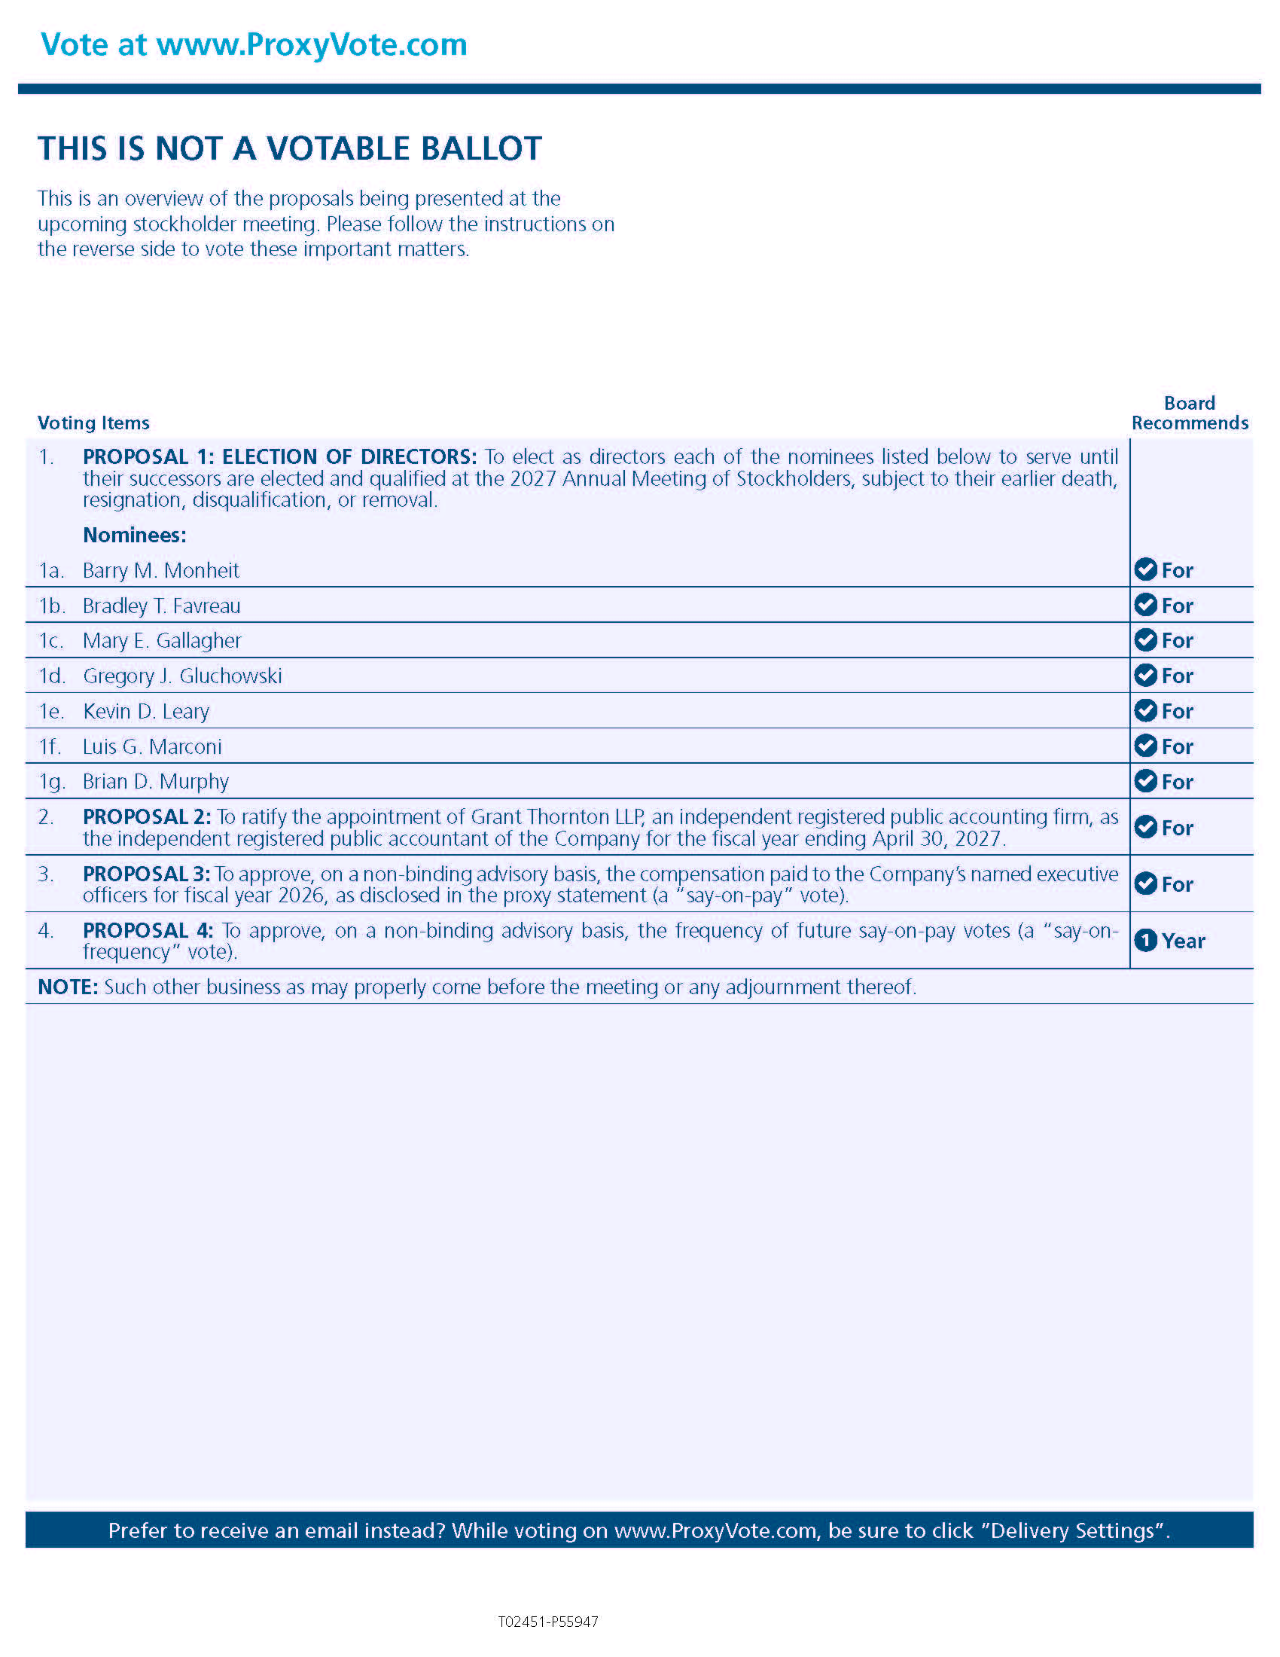
Vote at www.ProxyVote.com THIS IS NOT A VOTABLE BALLOTThis is an overview of the proposals being presented at the upcoming stockholder meeting. Please follow the instructions on the reverse side to vote these important matters. Board Recommends Voting Items 1. PROPOSAL 1: ELECTION OF DIRECTORS: To elect as directors each of the nominees listed below to serve until their successors are elected and qualified at the 2027 Annual Meeting of Stockholders, subject to their earlier death, resignation, disqualification, or removal. Nominees: 1a. Barry M. Monheit For 1b. Bradley T. Favreau For 1c. Mary E. Gallagher For 1d. Gregory J. Gluchowski For 1e. Kevin D. Leary For 1f. Luis G. Marconi For 1g. Brian D. Murphy For 2. PROPOSAL 2: To ratify the appointment of Grant Thornton LLP, an independent registered public accounting firm, as the independent registered public accountant of the Company for the fiscal year ending April 30, 2027. For 3. PROPOSAL 3: To approve, on a non-binding advisory basis, the compensation paid to the Company’s named executive officers for fiscal year 2026, as disclosed in the proxy statement (a "say-on-pay" vote). For 4. PROPOSAL 4: To approve, on a non-binding advisory basis, the frequency of future say-on-pay votes (a "say-on-frequency" vote). 1 Year NOTE: Such other business as may properly come before the meeting or any adjournment thereof. Prefer to receive an email instead? While voting on www.ProxyVote.com, be sure to click “Delivery Settings”. T02451-P55947

